**Project 3:- Design for Techy Software Company**

**Index**

* 1. Homepage1…………………………………………………………………………………………. 2
  2. Homepage2..…………………………………………………………………………………………5
  3. ChatBot…..…………………………………………………………………………………………...8
  4. About………………………………………………………………………………………………….. 14
  5. Portfolia……….……………………………………………………………………………………….17
  6. Service………………………………………………………………………………………………….20
  7. Contact/ Work with us……………………………………………………………………………. 23
  8. Blog……….……………………………………………………………………………………………. 26
  9. Blog Single……………………………………………………………………………………………. 29
  10. Book a Call…………………………………………………………………………………………….32
  11. Partnership Details……..…………………………………………………………………………. 35
  12. Product …………….……………….……………………………………………………………….. 39
  13. Product Download………………………………………………………………………………… 43
  14. Quote Request……………………………………………………………………………………….46
  15. Location………………………………………………………………………………………………..50
  16. 404 Error………………………………………………………………………………………………..53
  17. All Prototype photo………………………………………………………………………………….56
  18. **Homepage1**

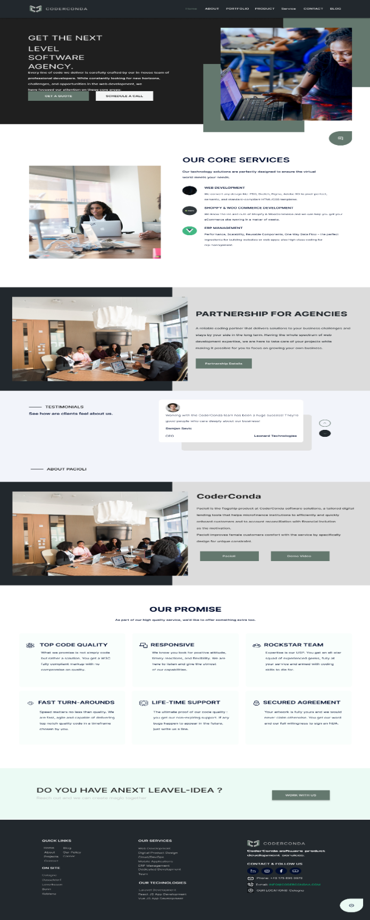

**Color Schemes:**

* Primary Colors: The primary color scheme appears to be a combination of shades of green and blue. These colors provide a modern, professional, and trustworthy feel, aligning with the brand’s goal of being a next-level software agency.
* Green: Used for buttons and highlights, representing growth, stability, and trust.
* Blue: Often associated with professionalism and reliability, used in images and accent elements.
* Neutral Colors: Blacks, whites, and grays are used for text, backgrounds, and sections to maintain readability and a clean, sophisticated look.

**Typography:**

* Primary Font: A Inter font is used throughout, which is modern and easy to read on screens.
* Headings: Bold, larger font sizes to ensure they stand out and grab attention.
* Body Text: Regular weight, smaller font size for readability.
* Buttons and Links: Uppercase letters are used for buttons and important links to draw attention and encourage action.

**User Flow and Navigation Decisions:**

**User Flow:**

* CTA Buttons: "Get a Quote" and "Schedule a Call" are placed prominently to encourage immediate action from potential clients.
* Imagery: Professional and relatable imagery to create a connection with the audience.

**Core Services Section:**

* Service Descriptions: Concisely described services with icons to quickly convey information.
* Visual Break: A clean layout with ample whitespace allows users to easily scan and understand the services offered.

**Partnership for Agencies:**

* Details Button: Encourages deeper engagement from other agencies looking to collaborate.

**Product Highlight (CoderConda):**

* Details and Demo Video: Provides an in-depth look at the flagship product, encouraging potential clients to learn more.

**Testimonials:**

* Client Feedback: Builds trust and credibility by showcasing positive reviews from satisfied clients.

**Our Promise:**

* Quality Assurance: Highlights the company’s commitment to quality and reliability, reassuring potential clients.

**Contact CTA:**

* Work With Us Button: A final call to action to encourage potential clients to reach out with their ideas.

**Navigation:**

**Top Navigation Bar:**

* Links: Home, About, Portfolio, Product, Service, Contact, Blog.
* Logo: Located at the top-left, linking back to the homepage for easy navigation.

**Footer Navigation:**

* Quick Links: For easy access to important pages.
* Contact Information: Includes contact details and social media links for easy outreach.

**Explanations:**

* Hero Section: Designed to capture attention immediately with a strong value proposition and clear calls to action.
* Core Services: Highlighted prominently to quickly inform visitors of what the company offers.
* Partnership and Product Sections: Provide more detailed information for visitors who want to delve deeper.
* Testimonials and Promises: Build trust and credibility, addressing potential clients' concerns about quality and reliability.
* Final CTA: Reinforces the desire for potential clients to initiate contact, ensuring a strong end to the user journey.
  1. **Homepage2**

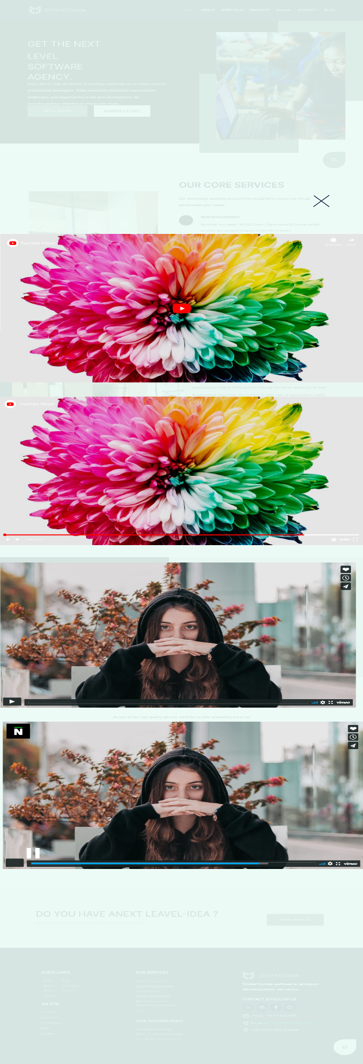

**Color Schemes:**

* Primary Colors: The primary colors remain consistent with the first design, utilizing shades of green and blue to convey professionalism and trust.
* Green: Emphasized in buttons and call-to-action elements.
* Blue: Featured in images and accent elements to maintain a cohesive visual theme.
* Neutral Colors: A combination of whites, grays, and blacks for text and background elements ensures readability and a clean, modern look.

**Typography:**

* Primary Font: A Inter font is used throughout, ensuring modernity and readability on digital devices.
* Headings: Bold and large for prominence.
* Body Text: Regular weight and smaller for easy reading.
* Buttons and Links: Uppercase letters for emphasis and action-oriented elements.

**User Flow and Navigation Decisions:**

**User Flow:**

* CTA Buttons: "Get a Quote" and "Schedule a Call" are prominently displayed to encourage immediate user engagement.
* Imagery: Professional and engaging images to capture attention and convey a relatable, human touch.

**Core Services Section:**

* Service Descriptions: Icons and brief descriptions provide a quick overview of the company's offerings, allowing users to scan and understand services easily.
* Visual Layout: Clean and spacious design for easy readability and visual appeal.

**Media Section:**

* YouTube Video: Embedded video for visual engagement and detailed information delivery.
* Vimeo Video: Another embedded video to showcase additional content, providing a rich multimedia experience.
* News Segment: Integration of a news segment (as seen with the "N" icon) to provide up-to-date and relevant information about the company or industry.

**Contact CTA:**

* Final Call to Action: "Work With Us" button to prompt potential clients to reach out with their ideas, ensuring a clear end-point for user engagement.

**Navigation:**

**Top Navigation Bar:**

* Links: Home, About, Portfolio, Product, Service, Contact, Blog for easy access to main sections.
* Logo: Positioned at the top-left, linking back to the homepage for seamless navigation.

**Footer Navigation:**

* Quick Links: Provides direct access to important pages.
* Contact Information: Includes social media links and contact details for easy outreach.

**Explanations:**

* Hero Section: Designed to capture user attention immediately with a strong value proposition and clear calls to action.
* Core Services: Highlighted prominently to quickly inform visitors of the company's offerings.
* Media Section: Adds dynamic content to engage users visually and provide detailed information through videos.
* Final CTA: Reinforces the desire for potential clients to initiate contact, providing a strong conclusion to the user journey.
  1. **ChatBot**

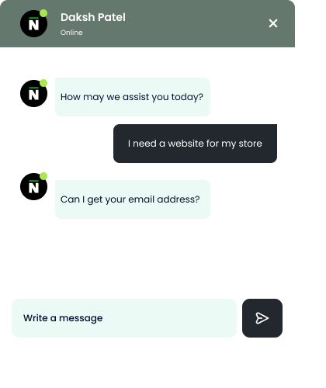

**Color Schemes:**

**Primary Colors:**

* Green: Used for the header background and status indicators (online status), representing growth, trust, and success.
* Black and White: Used for text and icons to ensure high contrast and readability.

**Accent Colors:**

* Light Green: Used for message bubbles sent by the chatbot, providing a subtle, calming effect.
* Dark Gray: Used for user message bubbles to differentiate user input from bot responses.

**Typography:**

* Primary Font: A Inter font is chosen for its modern look and readability.
* Chatbot Name: Bold and slightly larger to highlight the bot’s identity.
* Messages: Regular weight to maintain readability and a friendly appearance.
* User Input: Regular weight with clear separation from bot messages.

**User Flow and Navigation Decisions:**

**User Flow:**

**Chatbot Greeting:**

* Initial Message: "How may we assist you today?" to engage users immediately and prompt interaction.
* Online Indicator: Green dot next to the bot's name to indicate availability, reassuring users that they will receive a response.

**User Input:**

* Message Entry: Clear input field labeled "Write a message" encourages user participation.
* Send Button: Distinct and easily recognizable arrow icon for sending messages.

**Chatbot Response:**

* Request for Email: The bot requests the user's email address, indicating the start of a structured conversation aimed at gathering necessary information.

**User Continuation:**

* Ongoing Conversation: The design supports an ongoing dialogue with clearly separated messages, ensuring that users can easily follow the conversation.

**Explanations:**

* Color Scheme: The choice of green, black, and white ensures a professional, clean look while maintaining high readability and visual appeal. The green elements signal positivity and action.
* Typography: The Inter font is modern and easy to read, enhancing user experience. Bold text for the chatbot name distinguishes it, while regular text for messages maintains a friendly tone.

**Layout and Navigation:**

* The online status indicator (green dot) provides reassurance that the chatbot is active and responsive.
* The clear separation of bot and user messages with different background colors and text alignment (left for bot, right for user) helps users easily navigate the conversation.
* The input field and send button are prominently placed, making it straightforward for users to continue the interaction.
  1. **About**

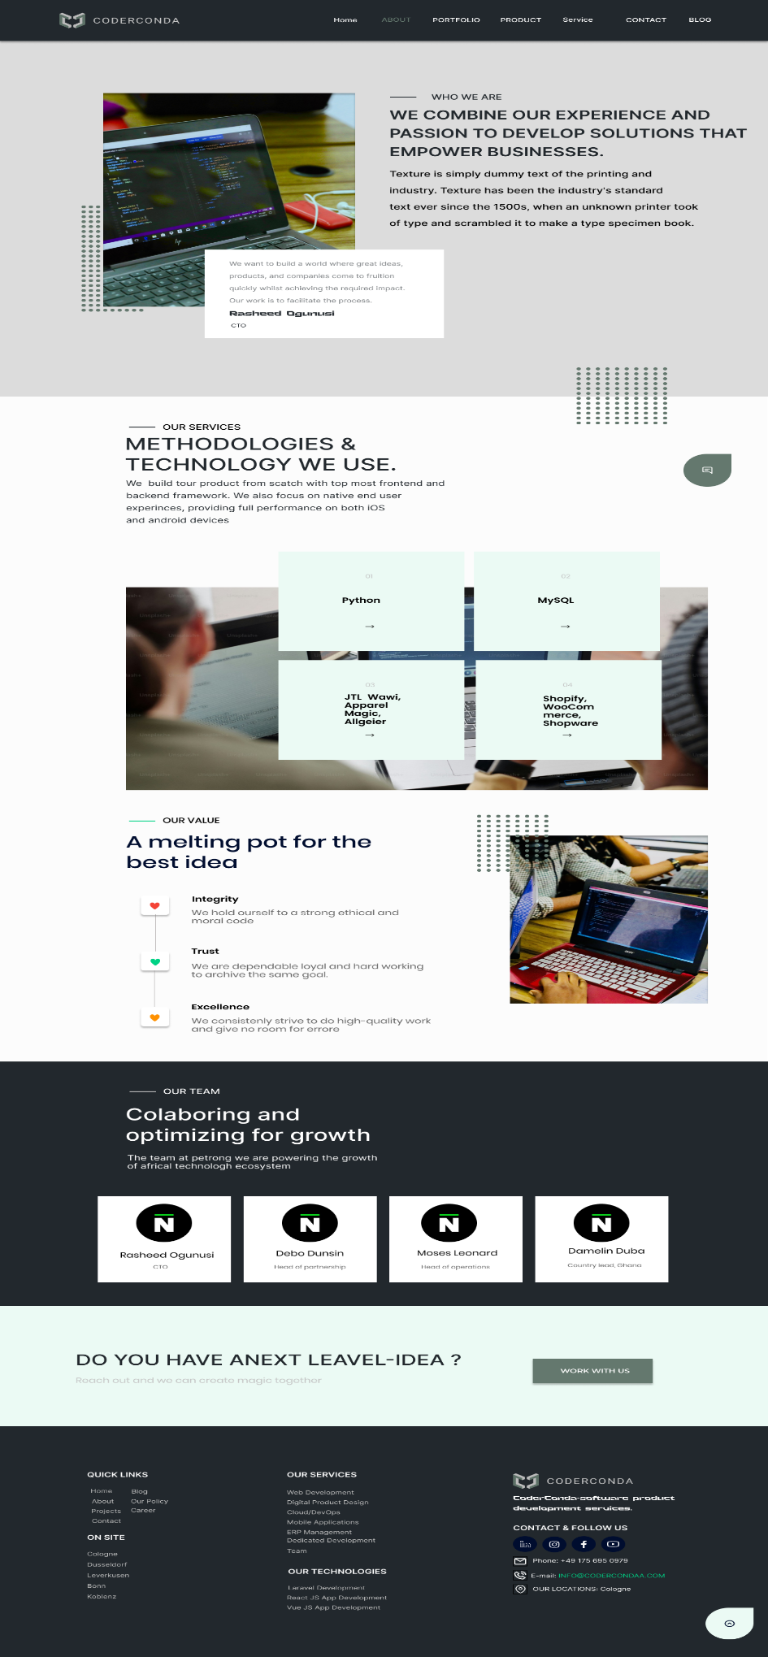

**Design Choices**

**Color Scheme:**

* Primary Colors: Dark Gray (#22282D) and White (#FCFCFC)
* Accent Colors: Light Green (#EBFAF4) and Light Gray (#F8F9FA)
* Text Colors: Black (#000000) for body text, Dark Gray (#DCDCDC) for headings, and White (#FCFCFC) for text on dark backgrounds.

**Explanation:**

* The dark gray and white combination creates a professional and clean look, suitable for a technology company.
* The light green and light gray accents add a touch of modernity and freshness without overwhelming the main content.
* Using black for body text ensures readability, while dark gray for headings provides a subtle hierarchy.

**Typography:**

* Headings: Inter, bold (e.g., Montserrat or Roboto Bold)
* Body Text: Inter, regular (e.g., Open Sans or Roboto Regular)
* Quotes and Highlights: Italicized Inter (e.g., Open Inter Italic)

**Explanation:**

* Inter fonts are clean and modern, which align with the tech-focused brand identity.
* Bold headings ensure clear section differentiation, making it easier for users to scan through content.
* Italicized text for quotes and highlights adds emphasis and helps distinguish important information.

**User Flow and Navigation Decisions:**

**Header Navigation:**

* Sections: Home, About, Portfolio, Product, Service, Contact, Blog

**Explanation:**

* These sections cover the primary information that potential clients and partners would look for.
* Keeping navigation options straightforward and descriptive helps users find what they need quickly.

**Main Content:**

**Who We Are Section:**

* Positioned at the top to introduce the company's mission and values immediately.
* Includes a quote from the CTO to add a personal touch and credibility.

**Our Services Section:**

* Detailed breakdown of methodologies and technologies used.
* Visual cards for each technology/tool, making it easy to scan and understand the company’s expertise.

**Our Value Section:**

* Highlights core values such as Integrity, Trust, and Excellence.
* Visual icons and short descriptions make the content engaging and easy to remember.

**Our Team Section:**

* Showcases key team members with their roles.
* Provides a sense of transparency and allows users to connect with the people behind the company.

**Call to Action:**

* "DO YOU HAVE A NEXT LEVEL IDEA?" section at the bottom with a "WORK WITH US" button.
* Encourages potential clients to reach out, facilitating lead generation.

**Footer Design:**

**Quick Links:**

* Provides easy access to important pages like Home, Blog, About, Projects, and Contact.

**Services and Technologies:**

* Lists the main services and technologies the company offers, reinforcing their expertise.

**Contact Information:**

* Includes phone number, email, and physical location for easy communication.
* Social media icons for additional ways to connect.
  1. **About**

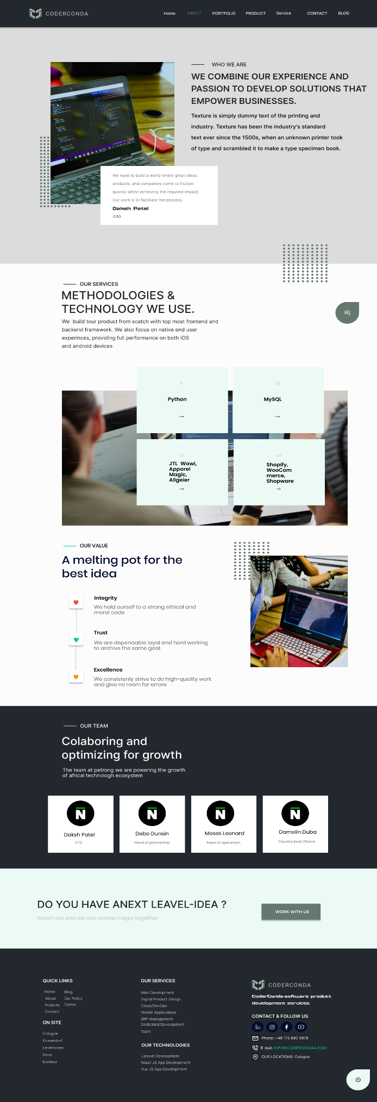

**Design Choices:**

**Color Scheme:**

**Primary Colors:**

* Dark Gray (#22282D): Used for the header, footer, and section titles to create a professional and modern look.
* Light Gray (#DCDCDC): Background color for sections to ensure good contrast and readability.

**Accent Colors:**

* Green (#EBFAF4): Used for interactive elements like buttons and icons to draw attention without overwhelming the user.
* White (#FCFCFC): For text and background in certain sections to maintain clarity and simplicity.

**Typography:**

**Primary Font:**

* Inter: Chosen for its readability and modern appearance. Used throughout the site for both headings and body text.

**Font Styles:**

* Bold: For headings and important text to create a clear hierarchy.
* Regular: For body text to ensure readability.

**User Flow and Navigation Decisions:**

**Navigation Bar:**

* Fixed Position: Ensures that the navigation bar is always accessible as users scroll through the site.
* Links: Home, About, Portfolio, Product, Service, Contact, and Blog. These cover the main sections a user would likely visit, providing clear paths to important information.

**Section Layout:**

**Hero Section (Who We Are):**

* Image: Engages users immediately with relevant visuals.
* Text: Clear and concise, explaining the company’s mission and values.

**Services Section:**

* Grid Layout: Divides the services into four categories, each with a brief description and arrow indicating more information.
* Icons and Images: Provide a quick visual understanding of the services offered.

**Values Section:**

* Vertical List: Clearly outlines the core values with accompanying icons to enhance understanding and engagement.
* Image: Supports the textual content and adds a personal touch.

**Team Section:**

* Profiles: Displaying key team members with their roles to humanize the company and build trust with potential clients.

**Call to Action:**

* Prominent Placement: At the bottom of the page to encourage users to take the next step after they have learned about the company.
* Button: Clear and inviting, prompting users to reach out with their ideas.

**Footer:**

* Quick Links: Ensures users can navigate to other important sections without having to scroll back to the top.
* Contact Information: Clearly displayed for easy access.
* Social Media Icons: Encourage users to connect on other platforms.

**Explanations for User Flow:**

* Ease of Access: Fixed navigation bar ensures users can easily move between sections without having to scroll excessively.
* Logical Sequence: Information is presented in a logical flow from introducing the company, showcasing services, highlighting values, presenting the team, and finally prompting user action.
* Visual Hierarchy: Clear distinctions between different types of content (e.g., headers, body text, images) guide the user’s eye and make the content easier to digest.
* By adhering to these design choices and navigation principles, the goal is to create a user-friendly, visually appealing, and informative website that effectively communicates the company’s message and services
  1. **Portfolio**

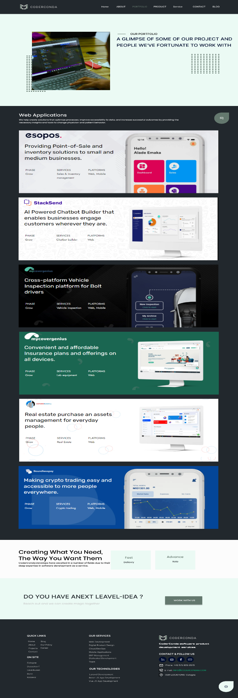

**Design Choices:**

**Color Scheme:**

**Primary Colors:**

* Dark Gray (#22282D): Consistent with the ABOUT page, used for the header, footer, and section titles to maintain a professional and cohesive look.
* Light Gray (#DCDCDC): Background color for sections to ensure good contrast and readability.

**Accent Colors:**

* Green (#EBFAF4): Used for interactive elements like buttons and icons to draw attention without overwhelming the user.
* White (#FFFFFF): For text and background in certain sections to maintain clarity and simplicity.

**Typography:**

**Primary Font:**

* Inter: Chosen for its readability and modern appearance. Used throughout the site for both headings and body text.

**Font Styles:**

* Bold: For headings and important text to create a clear hierarchy.
* Regular: For body text to ensure readability.

**User Flow and Navigation Decisions:**

**Navigation Bar:**

* Fixed Position: Ensures that the navigation bar is always accessible as users scroll through the site.
* Links: Home, About, Portfolio, Product, Service, Contact, and Blog. These cover the main sections a user would likely visit, providing clear paths to important information.

**Section Layout:**

**Hero Section (Our Portfolio):**

* Image: Engages users immediately with relevant visuals.
* Text: Clear and concise, providing an overview of the portfolio content.

**Portfolio Section:**

* Cards Layout: Each project is presented in a card format, making it easy to scan through multiple projects quickly.
* Images and Descriptions: Each card includes an image and a brief description of the project, highlighting key details such as phase, services, and platforms.

**Call to Action:**

* Prominent Placement: At the bottom of the page to encourage users to take the next step after they have reviewed the portfolio.
* Button: Clear and inviting, prompting users to reach out with their ideas.

**Footer:**

* Quick Links: Ensures users can navigate to other important sections without having to scroll back to the top.
* Contact Information: Clearly displayed for easy access.
* Social Media Icons: Encourage users to connect on other platforms.

**Explanations for User Flow:**

* Ease of Access: Fixed navigation bar ensures users can easily move between sections without having to scroll excessively.
* Logical Sequence: Information is presented in a logical flow from introducing the company, showcasing services, highlighting values, presenting the team, and finally prompting user action.
* Visual Hierarchy: Clear distinctions between different types of content (e.g., headers, body text, images) guide the user’s eye and make the content easier to digest.
* By adhering to these design choices and navigation principles, the goal is to create a user-friendly, visually appealing, and informative website that effectively communicates the company’s message and showcases their portfolio effectively.
  1. **Service**

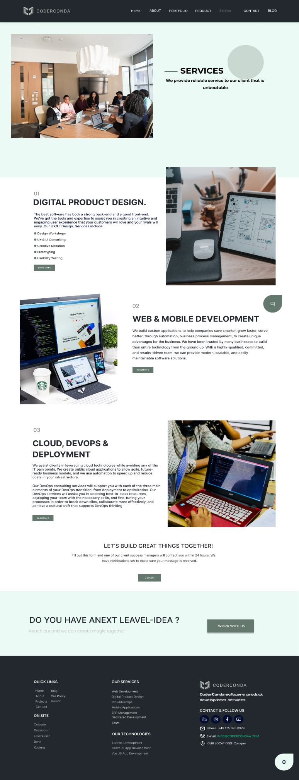

**Design Choices:**

**Color Scheme:**

**Primary Colors:**

* Dark Gray (#22282D): Consistent with the other pages, used for the header, footer, and section titles to maintain a professional and cohesive look.
* Light Gray (#DCDCDC): Background color for sections to ensure good contrast and readability.

**Accent Colors:**

* Green (#EBFAF4): Used for interactive elements like buttons and icons to draw attention without overwhelming the user.
* White (#FFFFFF): For text and background in certain sections to maintain clarity and simplicity.

**Typography:**

**Primary Font:**

* Inter: Chosen for its readability and modern appearance. Used throughout the site for both headings and body text.

**Font Styles:**

* Bold: For headings and important text to create a clear hierarchy.
* Regular: For body text to ensure readability.

**User Flow and Navigation Decisions:**

**Navigation Bar:**

* Fixed Position: Ensures that the navigation bar is always accessible as users scroll through the site.
* Links: Home, About, Portfolio, Product, Service, Contact, and Blog. These cover the main sections a user would likely visit, providing clear paths to important information.

**Section Layout:**

**Hero Section (Services):**

* Image: Engages users immediately with relevant visuals.
* Text: Clear and concise, providing an overview of the services offered.

**Service Offerings Section:**

* Three Columns Layout: Each service offering (Digital Product Design, Web & Mobile Development, Cloud, DevOps & Deployment) is presented in its own column, making it easy to differentiate between them.
* Images and Descriptions: Each service includes an image and a detailed description of what is provided, highlighting key details.

**Call to Action:**

* Prominent Placement: At the bottom of the page to encourage users to take the next step after they have reviewed the services.
* Form: Simple contact form with a clear button to submit inquiries.

**Footer:**

* Quick Links: Ensures users can navigate to other important sections without having to scroll back to the top.
* Contact Information: Clearly displayed for easy access.
* Social Media Icons: Encourage users to connect on other platforms.

**Explanations for User Flow:**

* Ease of Access: Fixed navigation bar ensures users can easily move between sections without having to scroll excessively.
* Logical Sequence: Information is presented in a logical flow from introducing the company, showcasing services, highlighting values, presenting the team, and finally prompting user action.
* Visual Hierarchy: Clear distinctions between different types of content (e.g., headers, body text, images) guide the user’s eye and make the content easier to digest.
* By adhering to these design choices and navigation principles, the goal is to create a user-friendly, visually appealing, and informative website that effectively communicates the company’s message and showcases their services effectively.
  1. **Contact/ Work with us**

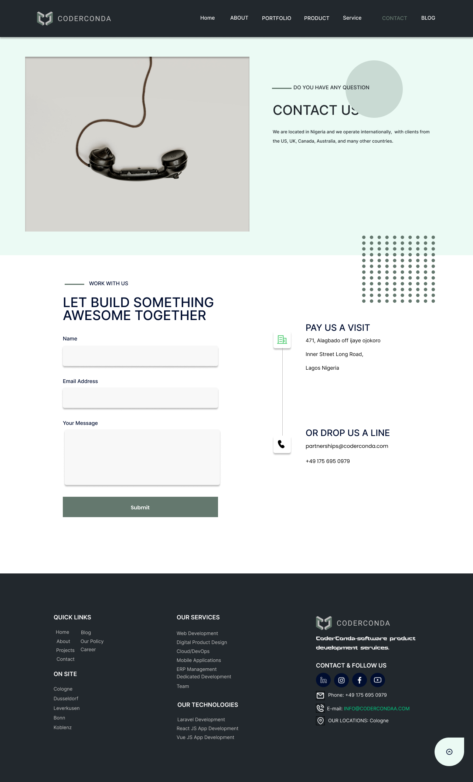

**Design Choices:**

**Color Scheme:**

**Primary Colors:**

* Dark Blue: Used for text and headings, providing a professional and trustworthy look.
* Light Green: Used for background and accent elements, giving a fresh and clean appearance.

**Accent Colors:**

* Grey: Used for background patterns and less prominent text, ensuring readability without overwhelming the user.

**Typography:**

**Headings:**

* Font: Inter, bold.
* Color: Dark Blue.
* Size: Larger than body text to ensure hierarchy and easy scanning.

**Body Text:**

* Font: Inter, regular weight.
* Color: Dark Blue and Grey.
* Size: Smaller than headings, optimized for readability.

**Imagery:**

* Minimalistic and relevant images, such as the telephone handset, which symbolizes communication, reinforcing the contact purpose of the page.

**User Flow and Navigation Decisions:**

**Navigation Bar:**

* Positioned at the top of the page for easy access.
* Includes essential links (Home, About, Portfolio, Product, Service, Contact, Blog) to help users find information quickly.

**Contact Section:**

* Prominent Position: Located at the top of the page to immediately direct users seeking to contact the company.
* Clear Call to Action: "Contact Us" is clearly labeled and accompanied by supportive text to encourage user interaction.

**Form Section:**

* Encouraging Collaboration: Headed with "Work with Us - Let's Build Something Awesome Together," inviting users to engage in partnership.
* Simple and Straightforward: Includes fields for Name, Email Address, and Message to minimize user effort and encourage form submission.
* Submit Button: Clearly labeled and prominently placed to facilitate easy form submission.

**Contact Information:**

* Physical Address: Provided for users who prefer traditional mail or in-person visits.
* Email and Phone: Direct contact details for immediate communication.
* International Presence: Highlights the global reach and availability of services.

**Footer:**

* Quick Links: Easy access to essential site sections (Home, About, Projects, Contact).
* On-Site Locations: Lists specific locations to establish a local presence.
* Services and Technologies: Outlines the services offered and technologies used, giving potential clients an overview of capabilities.
* Social Media Links: Encourages users to connect on various platforms, enhancing engagement and brand presence.

**Explanation:**

* The design choices aim to create a clean, professional, and user-friendly contact page. The color scheme balances trustworthiness and approachability, while the typography ensures readability and hierarchy. The user flow is designed to guide visitors smoothly from seeking information to taking action, whether through filling out the form or using the provided contact details. By placing essential information prominently and ensuring easy navigation, the design enhances user experience and encourages engagement.
  1. **Blog**

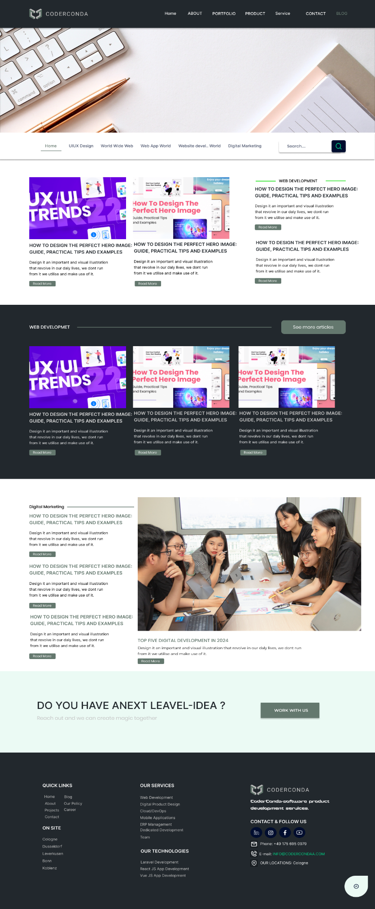

**Design Choices:**

**Color Scheme:**

**Primary Colors:**

* Dark Blue: Used for headers, text, and navigation bar to maintain consistency and provide a professional appearance.
* Light Green: Used for backgrounds and accents to keep the page light and readable.

**Accent Colors:**

* Grey: Used for secondary text and background elements to maintain a clean look without distracting from the main content.

**Typography:**

**Headings:**

* Font: Inter, bold.
* Color: Dark Blue.
* Size: Large to medium, ensuring clear hierarchy and easy navigation through the content.

**Body Text:**

* Font: Inter, regular weight.
* Color: Dark Blue and Grey.
* Size: Standard for readability and comfort during long reading sessions.

**Imagery:**

* Relevant and High-Quality Images: Used to complement the content and make the page visually appealing. For instance, the hero image related to UX/UI trends and the group image in the Digital Marketing section.

**User Flow and Navigation Decisions:**

**Navigation Bar:**

* Positioned at the top for easy access to different sections of the website.
* Includes key links (Home, About, Portfolio, Product, Service, Contact, Blog) to help users quickly find what they are looking for.

**Blog Section:**

* Category Tabs: Located just below the hero image, allowing users to filter content by topic (UI/UX Design, Web Development, Digital Marketing, etc.).
* Search Bar: Prominently placed for users to quickly find specific articles or topics.

**Content Layout:**

* Hero Section: Highlights the latest or featured articles with large images and clear headings to draw user attention.
* Article Previews: Each preview includes a title, brief description, and "Read More" button to entice users to click through for full articles.
* Consistent Design: Each article preview is designed similarly to maintain a uniform look and feel, aiding user familiarity and ease of navigation.

**Footer:**

* Quick Links: Easy access to important sections of the website, enhancing user navigation.
* Contact Information: Clearly displayed to encourage users to reach out.
* Social Media Links: Prominently placed to foster community engagement and extend reach.

**Explanation:**

* The design choices aim to create a visually appealing, professional, and user-friendly blog page. The color scheme balances professional and approachable tones, ensuring the page is engaging without being overwhelming. Typography is chosen for readability and hierarchy, making it easy for users to scan and navigate the content.
* User flow is designed to guide visitors smoothly through the page, from discovering new content in the hero section to exploring different topics via category tabs and the search bar. The consistent design of article previews helps users quickly identify and choose articles of interest. The footer provides additional navigation options and contact information, ensuring users can easily find what they need or get in touch.
* By maintaining a clean and organized layout, the design enhances the user experience, encouraging longer visits and increased engagement with the content.
  1. **Blog Single**

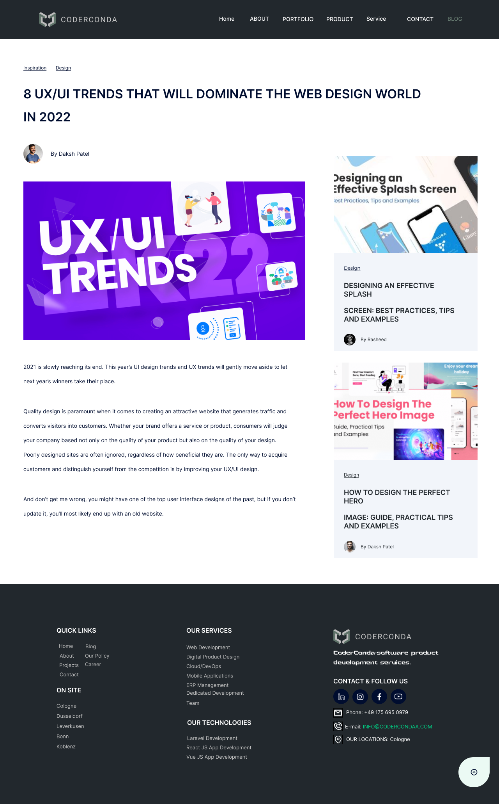

**Design Choices:**

**Color Scheme:**

**Primary Colors:**

* Dark Blue: Used for text, headers, and navigation elements to ensure a professional and cohesive look.
* Light Green: Utilized for background sections to maintain a fresh and clean appearance.

**Accent Colors:**

* Grey: Applied to secondary text and background elements to keep the design clean and uncluttered.

**Typography:**

**Headings:**

* Font: Inter, bold.
* Color: Dark Blue.
* Size: Large to ensure they stand out and are easily readable.

**Body Text:**

* Font: Inter, regular weight.
* Color: Dark Blue.
* Size: Standard for readability and comfort during longer reading sessions.

**Imagery:**

* Relevant Images:
* The main image related to UX/UI trends is prominently placed to draw attention.
* Side panel includes related article thumbnails to keep users engaged and encourage further reading.

**User Flow and Navigation Decisions:**

**Navigation Bar:**

* Positioned at the top for immediate access to other sections of the website.
* Includes key links (Home, About, Portfolio, Product, Service, Contact, Blog) for comprehensive site navigation.

**Article Layout:**

**Main Content Area:**

* Title: Large and bold to grab user attention.
* Author and Date: Displayed below the title to provide context.
* Main Image: Centrally placed to draw interest and visually break up the text.
* Content: Well-spaced paragraphs to enhance readability. The use of subheadings and bullet points for better content structure and easier scanning.

**Related Articles Sidebar:**

* Located on the right to suggest additional content to the reader, increasing engagement.
* Each related article includes a thumbnail, title, and brief description.

**Footer:**

* Quick Links: Provides easy access to essential sections of the website, improving overall navigation.
* Services and Technologies: Highlights the company’s offerings and expertise, promoting services to potential clients.
* Contact Information: Clearly displayed to encourage user interaction and inquiries.
* Social Media Links: Encourages users to connect on various platforms, fostering community engagement and extending reach.

**Explanation:**

* The design choices aim to create a visually appealing, professional, and user-friendly single blog post page. The color scheme maintains consistency with the overall brand, ensuring a unified look. Typography is chosen for clarity and readability, making the content accessible and engaging.
* The user flow is designed to guide visitors smoothly from the main content to related articles, encouraging longer visits and increased engagement. The layout ensures that the main article is the focus while providing easy access to additional content through the sidebar.
* By maintaining a clean and organized design, the page enhances the user experience, ensuring visitors can easily find and consume the content. The footer provides additional navigation options and contact information, ensuring users can quickly find what they need or get in touch
  1. **Book a Call**

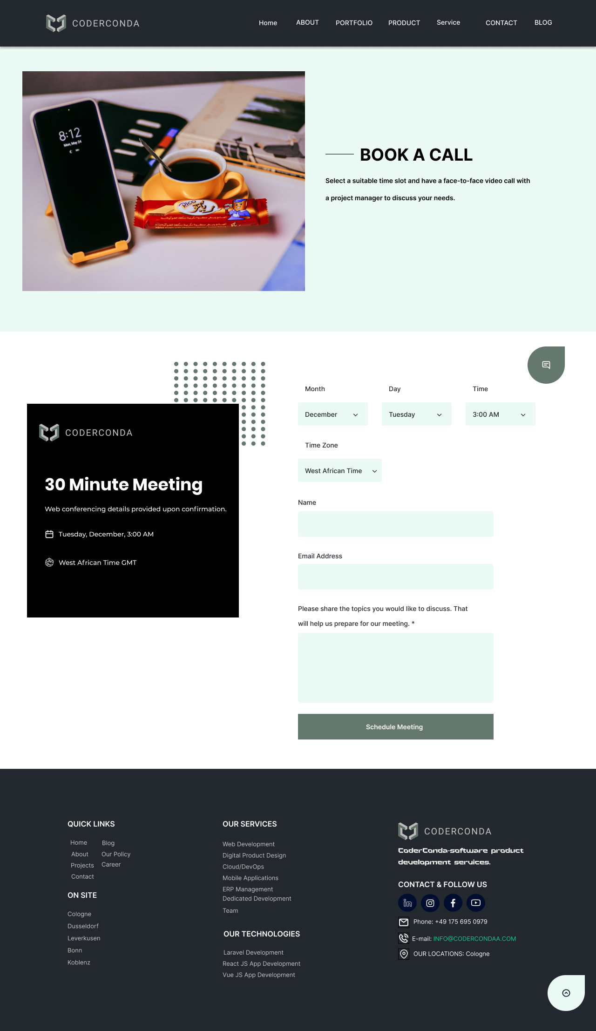

**Design Choices:**

**Color Scheme:**

* Primary Colors: A combination of dark green (for text and buttons) and light green (for background and form fields).
* Accent Colors: Dark grey and white, providing a neutral contrast to the primary colors.
* Purpose: The use of green shades conveys a professional and calming atmosphere, while the dark grey provides a strong, readable contrast.

**Typography:**

* Font Choices: Inter fonts are used for a modern and clean look.
* Heading: Bold and large font size to capture attention (e.g., "BOOK A CALL").
* Body Text: Regular weight for readability and consistency.
* Forms and Labels: Slightly lighter weight to differentiate from headings but still clear and legible.

**User Flow and Navigation Decisions:**

**Header Navigation:**

* Elements: Home, About, Portfolio, Product, Service, Contact, Blog.
* Purpose: Provides easy access to key sections of the website, ensuring users can navigate quickly to other relevant parts.

**Call to Action (CTA):**

* Primary CTA: "Book a Call" is prominently displayed with clear instructions.
* Secondary CTA: "Schedule Meeting" button at the bottom of the form to finalize the booking process.
* Purpose: Clear and direct CTAs guide users towards the main action, reducing friction in the booking process.

**Form Design:**

* Elements: Dropdowns for month, day, time, and time zone; input fields for name, email, and discussion topics.
* Purpose: Simplifies the process of scheduling a meeting, allowing users to specify their preferred time and relevant details.
* Validation: Ensures users fill in necessary details before submitting the form, improving the quality of bookings.

**Visual Hierarchy:**

* Image and Heading: Large image and bold heading at the top draw attention immediately.
* Form: Positioned prominently with clear labels and input fields.
* Additional Information: Contact details, services, and quick links are provided at the bottom for easy access to more information.

**Detailed Explanations:**

**Image and Heading:**

* Placement: Top of the page to immediately engage the user.
* Purpose: Visually appealing image paired with a bold heading helps users understand the purpose of the page instantly.

**Form Layout:**

* Dropdowns and Input Fields: Organized logically to guide the user step-by-step through the booking process.
* Time Zone Selection: Important for scheduling calls across different regions, ensuring clarity on meeting times.

**Footer Information:**

* Quick Links and Services: Enhances site navigation by providing direct links to other important sections.
* Contact Information: Clearly displayed for users who may have additional questions or need support.
  1. **Partnership Details**

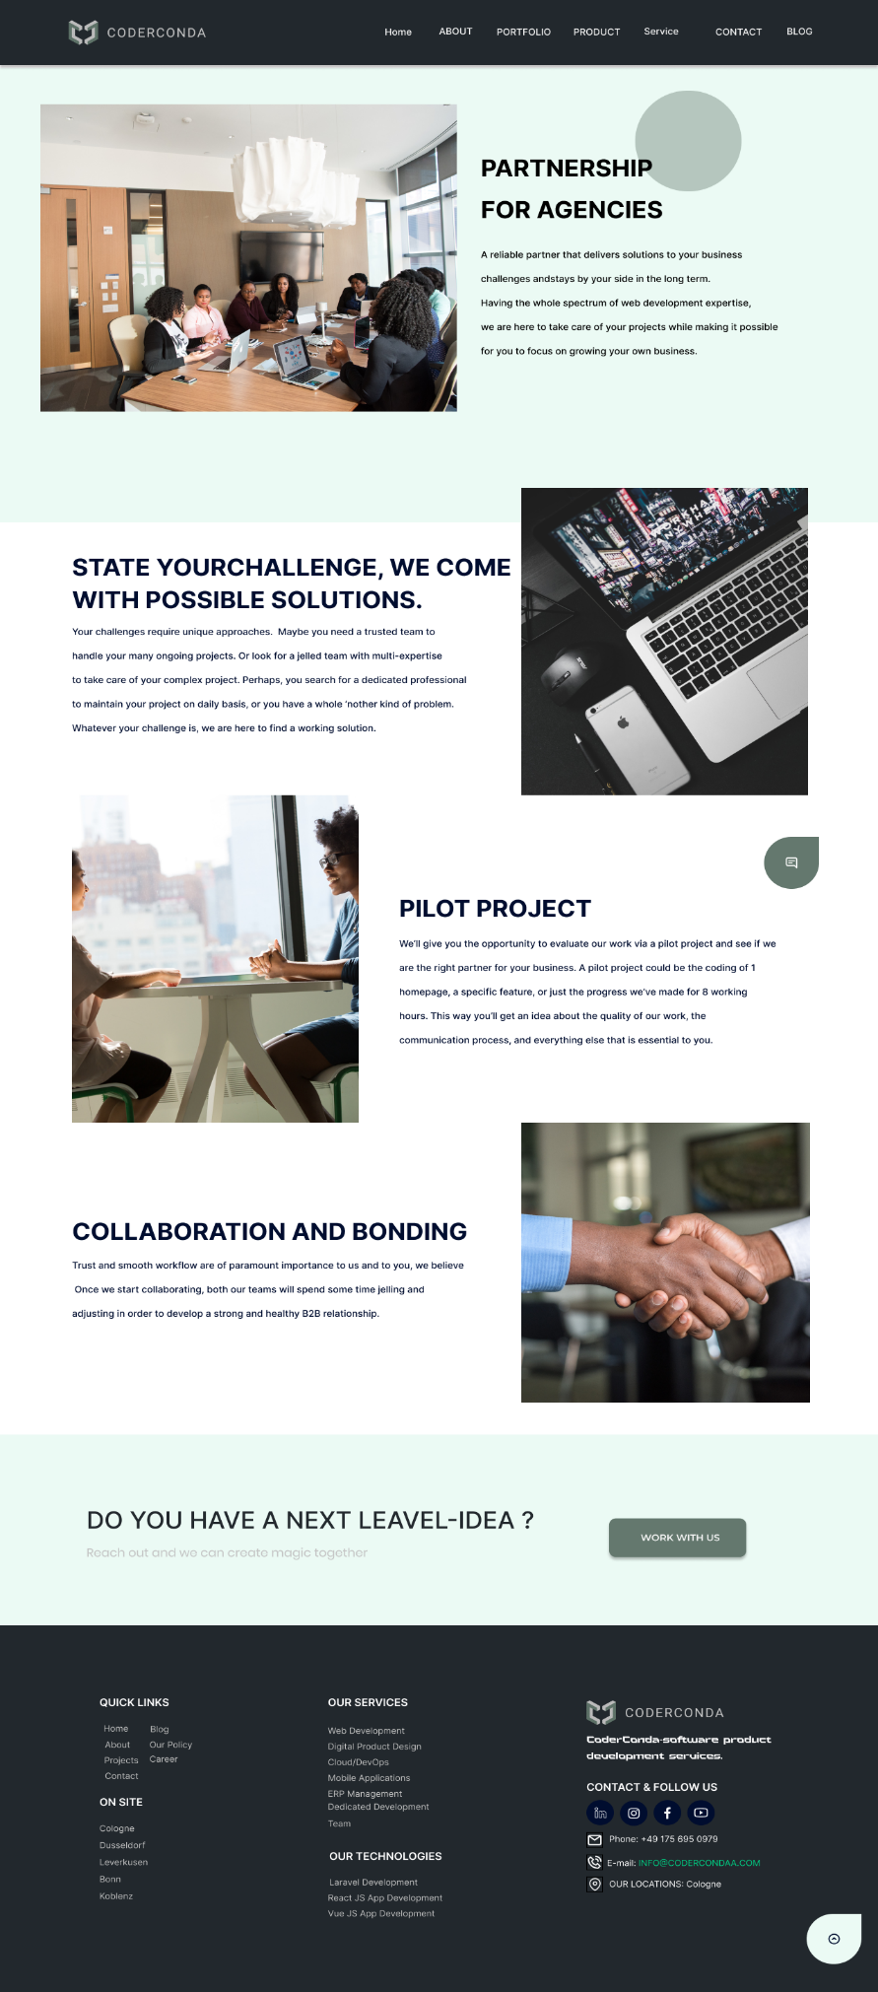

**Design Choices:**

**Color Scheme:**

* Primary Colors: The use of light green for the background gives a calm and professional feel. The dark grey and white for the text provide good contrast for readability.
* Accent Colors: Dark green is used for buttons and important highlights, ensuring they stand out to users.

**Typography:**

* Font Choices: The page uses Inter fonts, consistent with modern design trends, ensuring clarity and readability.
* Headings: Bold and large font sizes are used for headings, making key sections and information easily identifiable.
* Body Text: Regular weight fonts ensure readability and a clean look.
* Callouts: Specific phrases or sections (like “PARTNERSHIP FOR AGENCIES”) use bold and capitalized text to draw attention.

**User Flow and Navigation Decisions:**

**Header Navigation:**

* Elements: Home, About, Portfolio, Product, Service, Contact, Blog.
* Purpose: Provides easy access to main sections of the website, ensuring users can quickly navigate to other areas of interest.

**Main Content:**

* Sections: The page is divided into distinct sections:
* Introduction: "Partnership for Agencies" with a supporting image.
* Challenges and Solutions: Highlighting the value proposition and capabilities.
* Pilot Project: Offering a tangible way for users to evaluate the partnership.
* Collaboration and Bonding: Emphasizing the importance of teamwork and trust.
* Call to Action: Encouraging users to reach out with a compelling question and CTA button ("WORK WITH US").
* Purpose: Each section guides the user through understanding the benefits of partnering with the agency, addressing potential concerns, and encouraging engagement.

**Call to Action (CTA):**

* Primary CTA: "WORK WITH US" button is prominently displayed at the bottom of the page, inviting users to take the next step.
* Purpose: Clear and direct CTAs help convert visitors into potential partners by prompting immediate action.

**Visual Hierarchy:**

* Images and Headings: Large images and bold headings are used to break up the text and make the content more engaging and easier to digest.
* Text Blocks: Information is presented in short paragraphs with headings, making it easy for users to scan and find relevant details.

**Detailed Explanations:**

**Introduction Section:**

* Image and Heading: The large image of a team meeting and the bold heading immediately convey a sense of professionalism and partnership.
* Purpose: To engage users visually and communicate the main theme of the page upfront.

**Challenges and Solutions Section:**

* Text Layout: Bold heading followed by explanatory text that addresses common challenges and offers solutions.
* Purpose: To build trust by showing an understanding of the user's needs and how the agency can meet them.

**Pilot Project Section:**

* Explanation: Details on how users can start with a pilot project to evaluate the agency’s work.
* Purpose: Reduces commitment anxiety by offering a trial opportunity, helping users make an informed decision.

**Collaboration and Bonding Section:**

* Focus: Emphasizes the importance of building strong, collaborative relationships.
* Purpose: To reassure potential partners of the agency’s dedication to effective teamwork and long-term partnerships.

**Footer Information:**

* Quick Links and Services: Provides additional navigation options and highlights the range of services offered.
* Contact Information: Clearly displayed for users who may have additional questions or need support.

**Purpose:**

* Ensures users have easy access to further resources and contact details, improving overall user experience

**1.12 Product**

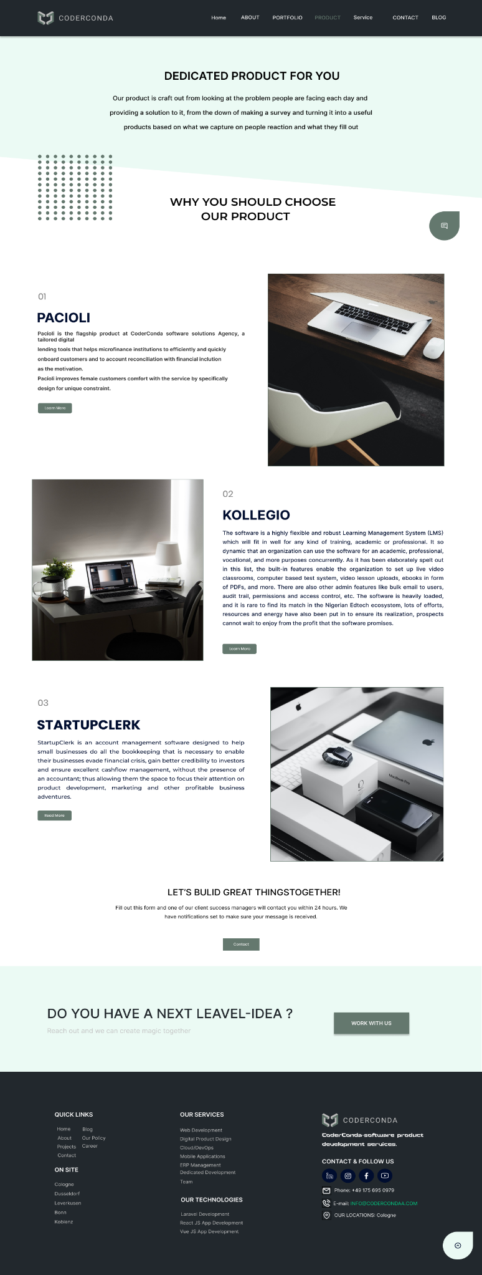

**Design Choices:**

**Color Scheme:**

* Primary Colors: Light green background provides a calm and professional ambiance.
* Accent Colors: Dark green for buttons and headers to draw attention, white for text areas to ensure readability, and dark grey for footer background to create a strong visual base.
* Purpose: The color scheme is chosen to be pleasing to the eye while highlighting important elements and maintaining a professional appearance.

**Typography:**

* Font Choices: Inter fonts are used throughout the design for a modern, clean look.
* Headings: Bold and large font sizes make headings stand out (e.g., "DEDICATED PRODUCT FOR YOU").
* Body Text: Regular weight for readability and consistency.
* Highlights: Important sections or key points use bold text to draw attention (e.g., product names).

**User Flow and Navigation Decisions:**

**Header Navigation:**

* Elements: Home, About, Portfolio, Product, Service, Contact, Blog.
* Purpose: Ensures users can easily navigate to other sections of the website from any page.

**Main Content:**

**Sections:**

* Introduction: The page starts with an overarching statement about the product’s dedication to solving user problems.
* Why You Should Choose Our Product: This section emphasizes the value proposition of the products offered.
* Product Details: Three products (Pacioli, Kollegio, StartupClerk) are highlighted, each with a brief description and image.
* Call to Action: "Let's Build Great Things Together!" with a contact form invitation.
* Purpose: To guide the user through understanding the unique offerings of each product and encourage them to reach out for more information or collaboration.

**Call to Action (CTA):**

* Primary CTA: "WORK WITH US" button prominently displayed, inviting users to initiate contact.
* Secondary CTA: "Contact" button at the end of the contact form section.
* Purpose: Clear and direct CTAs guide users to take the next step in engaging with the agency, whether it’s reaching out for collaboration or more information.

**Visual Hierarchy:**

* Images and Headings: Large images and bold headings are used to break up text and make the content more engaging and easy to scan.
* Text Blocks: Information is presented in easily digestible blocks, with clear headings and subheadings.

**Detailed Explanations:**

**Introduction Section:**

* Text and Layout: The introduction text provides a concise overview of the company’s approach to product development.
* Purpose: To immediately convey the company’s commitment to addressing user needs with dedicated products.

**Why You Should Choose Our Product Section:**

* Heading and Supporting Text: Clearly states the benefits of choosing the company’s products.
* Purpose: To build trust and interest by highlighting the company’s unique value proposition.

**Product Details Section:**

* Product Highlights: Each product is presented with an image, a title, and a description.
* Pacioli: Focuses on microfinance institutions and financial inclusion.
* Kollegio: Emphasizes the versatility and robust features of their Learning Management System.
* StartupClerk: Highlights the benefits for small businesses in managing finances and gaining investor credibility.
* Purpose: To provide detailed information about each product, helping users understand their specific benefits and applications.

**Call to Action Section:**

* Text and Contact Form: Encourages users to reach out with their next "great idea" and provides a form for contact.
* Purpose: To facilitate user engagement and inquiries, making it easy for potential clients to connect with the company.

**Footer Information:**

* Quick Links and Services: Enhances site navigation by providing direct links to important sections.
* Contact Information: Clearly displayed for users who may have additional questions or need support.
* Purpose: Ensures users have easy access to further resources and contact details, improving overall user experience.

**1.13 Product Download**

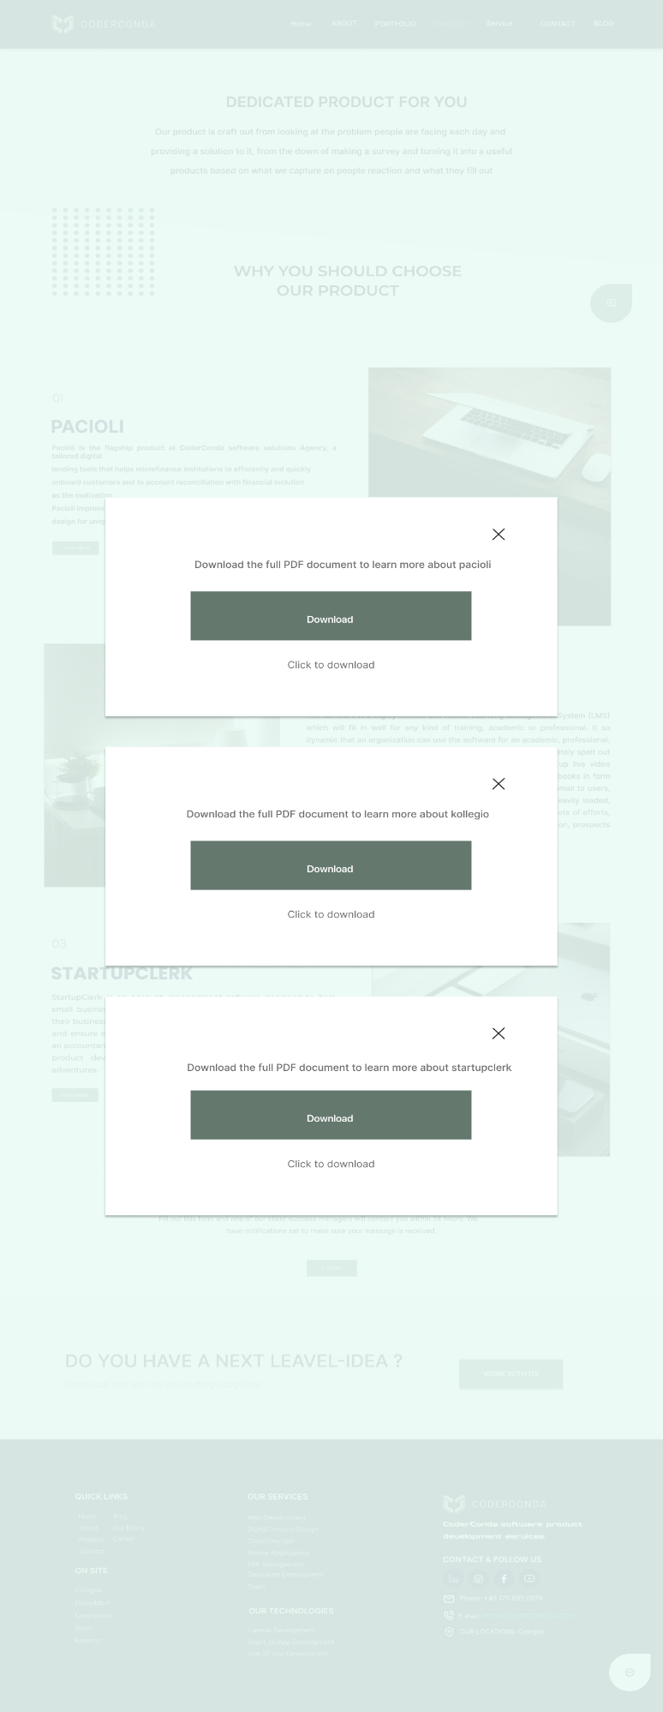

**Design Documentation:**

**Design Choices:**

* Minimalistic Layout: The design employs a clean and minimalistic layout to ensure easy readability and navigation.
* Consistent Branding: The design maintains consistent branding with the use of the logo and color scheme throughout the website.
* Focus on Content: The layout prioritizes content visibility with ample white space and well-defined sections.

**Color Scheme:**

* Primary Colors:
* Light Grey (#F0F4F8): Background color used to create a neutral and professional look.
* Dark Grey (#333333): Text color for high contrast and readability.

**Accent Colors:**

* Green (#4CAF50): Used for download buttons and links to draw attention to calls to action.
* Light Green (#A5D6A7): Hover effects on interactive elements to enhance user interaction.

**Typography:**

* Primary Font: Inter font used for its clean and modern appearance, ensuring readability across different devices.

**Headings:**

* Font Size: Large for main headings to create a clear hierarchy.
* Weight: Bold to distinguish headings from body text.

**Body Text:**

* Font Size: Medium, ensuring readability without overwhelming the user.
* Line Height: Generous to enhance readability and create a comfortable reading experience.

**User Flow and Navigation:**

**Main Navigation Bar:**

* Located at the top of the page with links to key sections (Home, About, Portfolio, Product, Service, Contact, Blog).
* Consistent across all pages to provide a familiar navigation experience.

**Hero Section:**

* Contains a concise introduction to the product offering, immediately engaging the user.
* Clear call-to-action buttons (e.g., "Learn More") to guide users towards further information.

**Product Sections:**

* Each product (Pacioli, Kollegio, StartupClerk) has its dedicated section with a brief description and a call-to-action button.
* Download prompts for detailed PDFs provide additional information.

**Footer:**

* Contains quick links to important pages and services.
* Contact information and social media links to encourage user engagement.
* Prominent "Work With Us" button to attract potential clients or collaborators.

**Interactive Elements:**

**Download Buttons:**

* Clearly labeled and centrally positioned within each product section.
* Designed to stand out with a green color and hover effect to indicate interactivity.

**Modal Windows:**

* Appear when a user clicks the download button, providing an option to download the full PDF document.
* Include a close button for easy dismissal.

**User Experience Considerations:**

**Accessibility:**

* High contrast between text and background ensures readability for users with visual impairments.
* Clear and concise language used in descriptions and calls to action.

**Responsiveness:**

* Design is optimized for various devices, ensuring a seamless experience on desktops, tablets, and smartphones.
  1. **Quote Request**

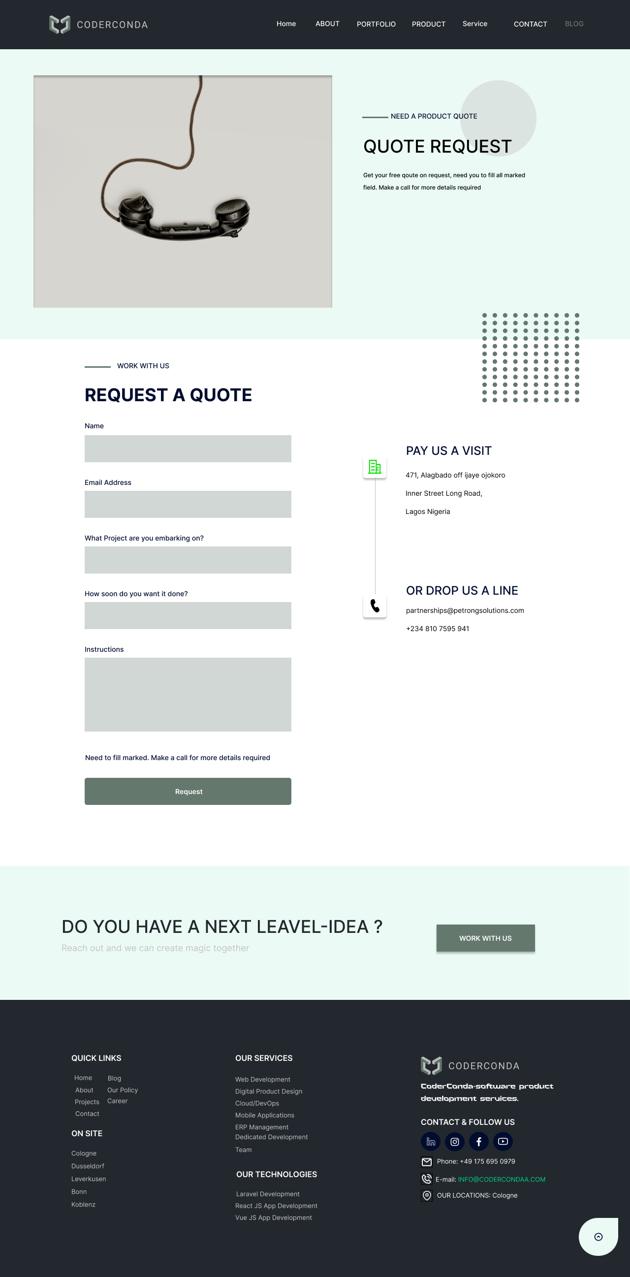

**Design Documentation:**

**Design Choices:**

* Professional Layout: The design uses a structured and professional layout to create a formal and trustworthy appearance.
* Balanced Visuals and Forms: The use of a large visual (telephone image) balances the page, making it visually appealing without overwhelming the form section.
* Clear Sectioning: Different sections (form, contact information, footer) are clearly delineated to guide the user effortlessly through the page.

**Color Scheme:**

**Primary Colors:**

* Light Mint (#EBFAF4): Background color providing a calm and professional atmosphere.
* Dark Grey (#22282D): Header and footer background color for strong contrast and focus on content.

**Accent Colors:**

* Green (#04DD00): Used for the "Request" button and hover effects, highlighting interactive elements.
* Dark Blue (#22282D): Used for headings and important text to create a visual hierarchy and ensure readability.

**Typography:**

* Primary Font: Inter font for a modern, clean, and professional look.

**Headings:**

* Font Size: Large and bold to clearly distinguish headings from other text.
* Color: Dark Blue to ensure they stand out and are easily readable.

**Body Text:**

* Font Size: Medium, ensuring readability without overwhelming the user.
* Line Height: Generous to enhance readability and create a comfortable reading experience.

**User Flow and Navigation:**

**Main Navigation Bar:**

* Located at the top of the page with links to key sections (Home, About, Portfolio, Product, Service, Contact, Blog).
* Consistent across all pages to provide a familiar navigation experience.

**Hero Section:**

* Features an engaging image (telephone) to draw users' attention immediately.
* Brief introductory text to inform users about the purpose of the page (quote request).

**Form Section:**

* Clearly labeled fields for user input (Name, Email Address, Project Description, Timeline, Instructions).
* Instructional text to guide users on required fields and provide additional context.
* Prominent "Request" button to submit the form, designed in green to stand out.

**Contact Information:**

* Positioned to the right of the form, providing additional ways to reach out (address, email, phone number).
* Uses icons for quick visual reference and to enhance readability.

**Footer:**

* Contains quick links to important pages and services for easy access.
* Contact information and social media links to encourage user engagement.
* Prominent "Work With Us" button to attract potential clients or collaborators.

**Interactive Elements:**

**Form Fields:**

* Clearly labeled with sufficient spacing to avoid clutter.
* Designed with light grey backgrounds to differentiate them from the rest of the content.

**Submit Button:**

* "Request" button in green to indicate it is an actionable item.
* Hover effect to signal interactivity and enhance user experience.

**Contact Information:**

* Includes icons and is placed adjacent to the form for easy access and improved usability.

**User Experience Considerations:**

**Accessibility:**

* High contrast between text and background ensures readability for users with visual impairments.
* Clear and concise language used in descriptions and calls to action.

**Responsiveness:**

* Design is optimized for various devices, ensuring a seamless experience on desktops, tablets, and smartphones.

**Load Time:**

* Minimalistic design helps in reducing load times, improving overall user experience.
  1. **Location**

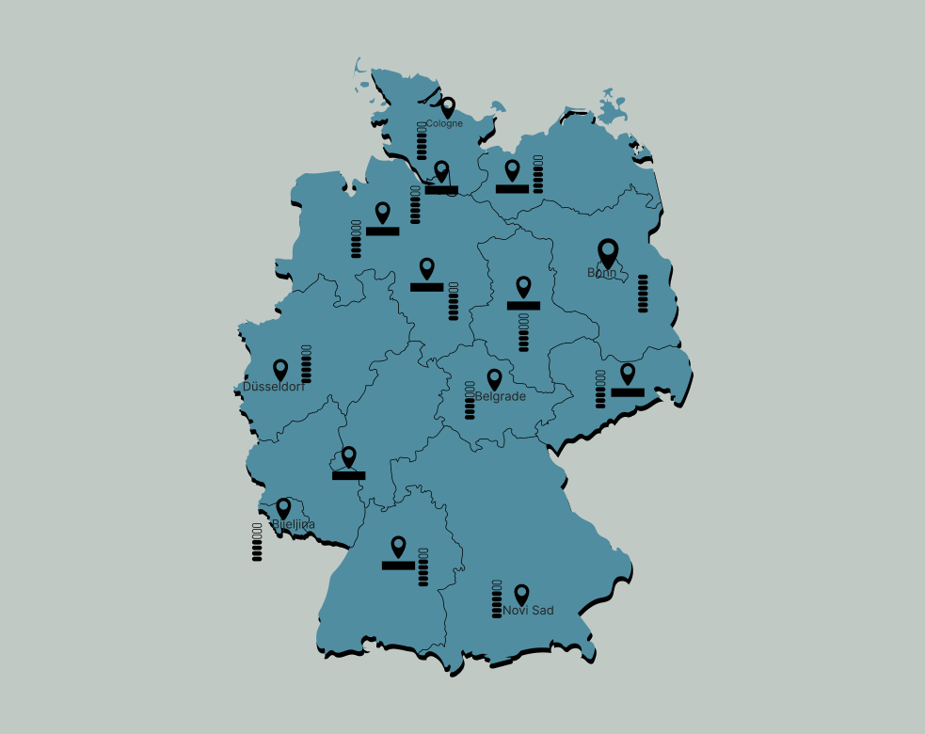

**Design Choices:**

**Map Outline and Regions:**

* The map highlights Germany with its internal regions.
* The regions are not labeled by state names but are distinguished by their boundaries.

**Locations:**

* Specific cities are marked with location pins, suggesting points of interest or key data points.

**The cities include:**

* Cologne
* Düsseldorf
* Bjeljina
* Belgrade
* Novi Sad
* Bonn

**Icons and Symbols:**

* Location markers (pins) are used to indicate cities.
* Bars or columns beside the location markers possibly represent data such as population, economic factors, or other metrics.

**Color Scheme:**

**Primary Colors:**

* The map's background is a medium-dark teal, providing a cool and neutral base.
* Cities and icons are in black, which stands out clearly against the teal background.

**Contrast and Readability:**

* The high contrast between the teal map background and the black icons ensures readability and easy identification of locations.

**Typography:**

**Font Style:**

* The font used for city names appears to be a Inter type, which is modern and clean.
* The choice of Inter ensures that text is legible at smaller sizes.

**Font Size and Weight:**

* City names are appropriately sized to be readable without overpowering the visual hierarchy of the map.
* Boldness in the font weight is moderate, ensuring clarity without excessive prominence.

**User Flow and Navigation Decisions:**

**User Flow:**

* The map is designed for a straightforward and intuitive user experience.
* Users are expected to quickly identify and locate cities of interest based on the location pins and associated data bars.

**Navigation:**

* There are no interactive elements visible in the image, such as clickable areas or buttons.
* If this map were part of an interactive application, it would likely allow users to click on cities for more detailed information.

**Decision Rationale:**

* The use of pins and bars suggests an emphasis on specific data points for each location. This could imply a purpose such as economic analysis, population study, or other metric-based evaluations.
* Keeping the design minimalistic with only essential information (location names and data representation) helps maintain focus and avoids clutter.

**Additional Considerations:**

**Accessibility:**

* Color contrast meets accessibility standards, ensuring readability for users with visual impairments.
* The use of symbols (pins and bars) alongside text aids in understanding for users with different cognitive preferences.

**Scalability:**

* The design is scalable; it can be adjusted for various screen sizes and resolutions without losing clarity or functionality.
* Elements are spaced adequately to avoid overlap, maintaining clarity on both small and large displays.

**1.16 404 Error**

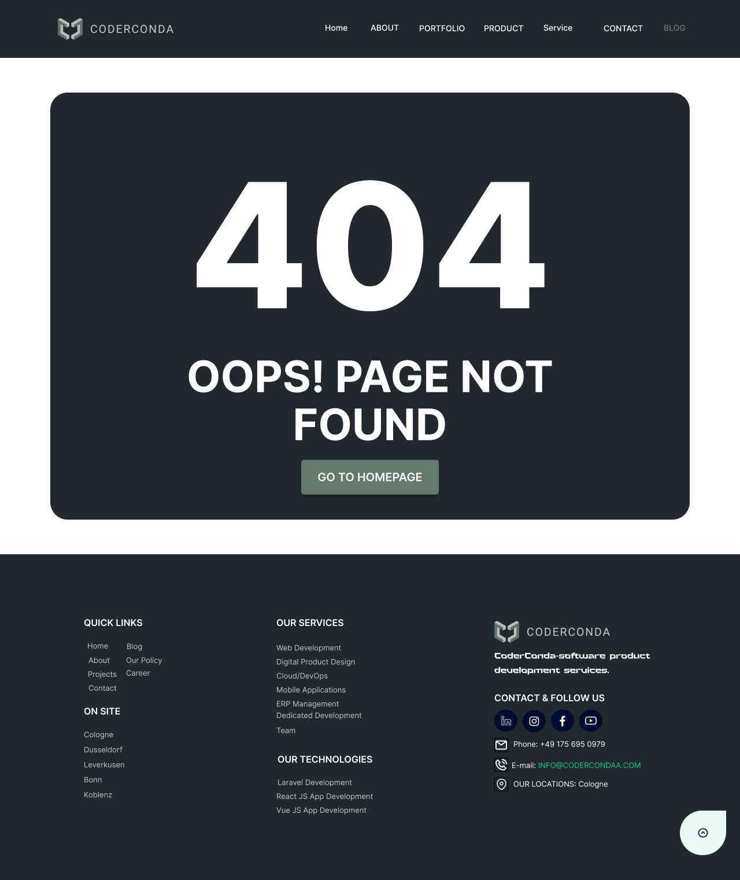

**Design Choices:**

**Minimalistic Design:**

* The design follows a minimalistic approach which helps in focusing the user's attention on the key message - the 404 error.
* Large font size for the "404" error code and the "Oops! Page Not Found" message ensures that the error message is immediately clear to the user.

**Color Scheme:**

* Primary Color: Dark gray (#22282D) for the background of the error message to create a strong contrast with the white text.
* Text Color: White (#FFFFFF) for the main error message to ensure readability against the dark background.
* Button Color: Soft green (#64786E) for the "Go to Homepage" button to make it stand out and be easily noticeable as a call-to-action.

**Typography:**

* Header Font Size: The "404" is very large, likely around 100-150px, to grab attention.
* Subheader Font Size: The "Oops! Page Not Found" message is slightly smaller, around 24-36px, but still prominent.
* Button Font Size: The "Go to Homepage" button text is readable, probably around 16-20px.
* Font Style: Inter fonts are used throughout for a modern and clean look.

**User Flow and Navigation Decisions:**

**Immediate Feedback:**

* The large "404" and accompanying message provide immediate feedback to the user that they have encountered an error page.

**Call to Action:**

* The "Go to Homepage" button is strategically placed and designed to be easily noticeable, providing a clear path for the user to return to the main site.

**Footer Navigation:**

* The footer includes additional links under "Quick Links", "Our Services", and "Our Technologies", allowing users to navigate to other parts of the site if the homepage is not their desired destination.
* Contact information and social media links are provided to help users reach out or follow the company easily.

**Consistent Branding:**

* The logo and consistent color scheme throughout the page ensure the user knows they are still on the same site despite encountering an error.
* The footer includes detailed information about the company’s services, reinforcing the brand identity.

**Information Hierarchy:**

* Important information (error message and call-to-action) is prominently displayed in the center.
* Additional navigation options and company information are available but placed secondary to the main error message, ensuring the user's primary focus remains on resolving their navigation issue.
* By using these design choices and navigation strategies, the error page not only informs the user of the issue but also provides them with clear and immediate solutions, enhancing the overall user experience.

**1.17 All Prototype Photo**

